**BANKS**

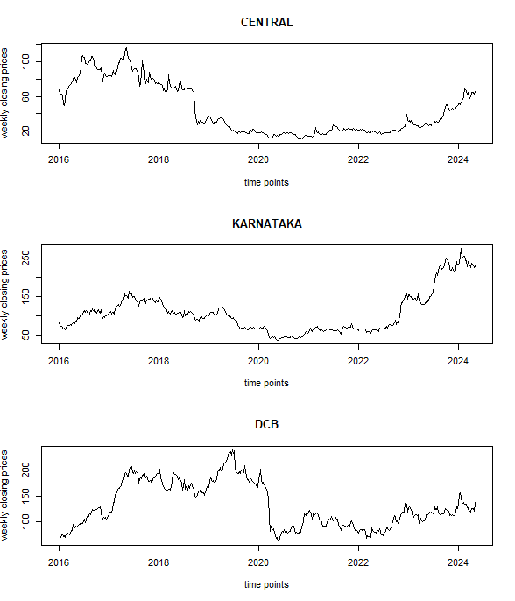

From the Figure we observe that the data is not stationary. There is decrease of stock price after Covid-19 for the three Banks but DCB has sharp decrease than Central Bank and Karnataka Bank.

**FOOD PROCESSING**

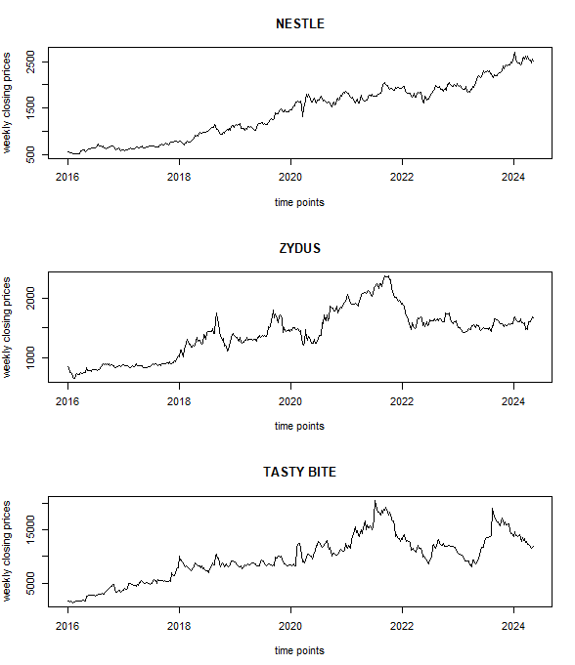

From the figure , we observe that the data is not stationary, only a slight decrease is found during initial Covid – 19 period for all the three food processing companies . Trend is present in the data.

**TELECOMMUNICATION**

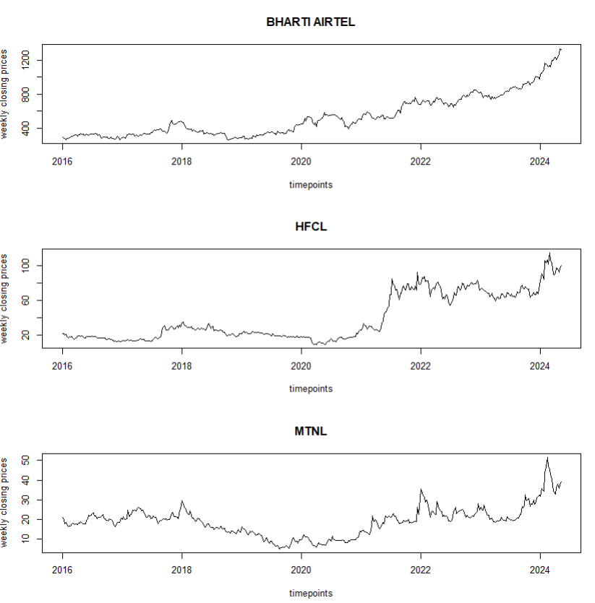

From the Figure 1 we observe that the data is not stationary, there is sharp increase and sharp decrease at some points. Trend is present in the data

**INFORMATION TECHNOLOGY**

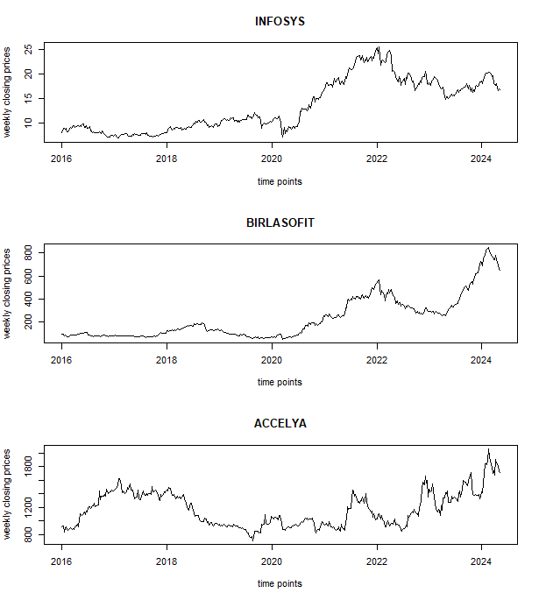

From the Figure 1 we observe that the data is not stationary, there is sharp increase and sharp decrease at some points. Trend is present in the data

**JEWELLERY AND GEM**

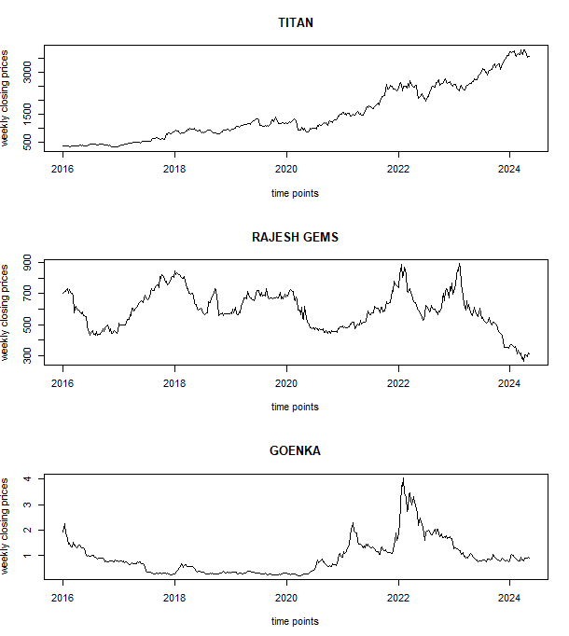

From the Figure 1 we observe that the data is not stationary, there is sharp increase and sharp decrease at some points. Trend is present in the data